**Enes Garip-150116034**

**CSE225 DATA STRUCTURES REPORT**

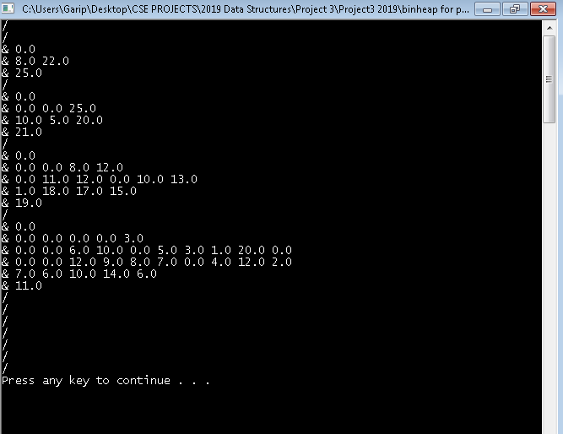

I want to read the input file and then add the numbers that the program requires. There is a problem that i can not solve is all of the input file is added to the binary heap such as process id’s as a value of zero. There is also a part of code that tries to add the input file to the array part by part but it does not work.